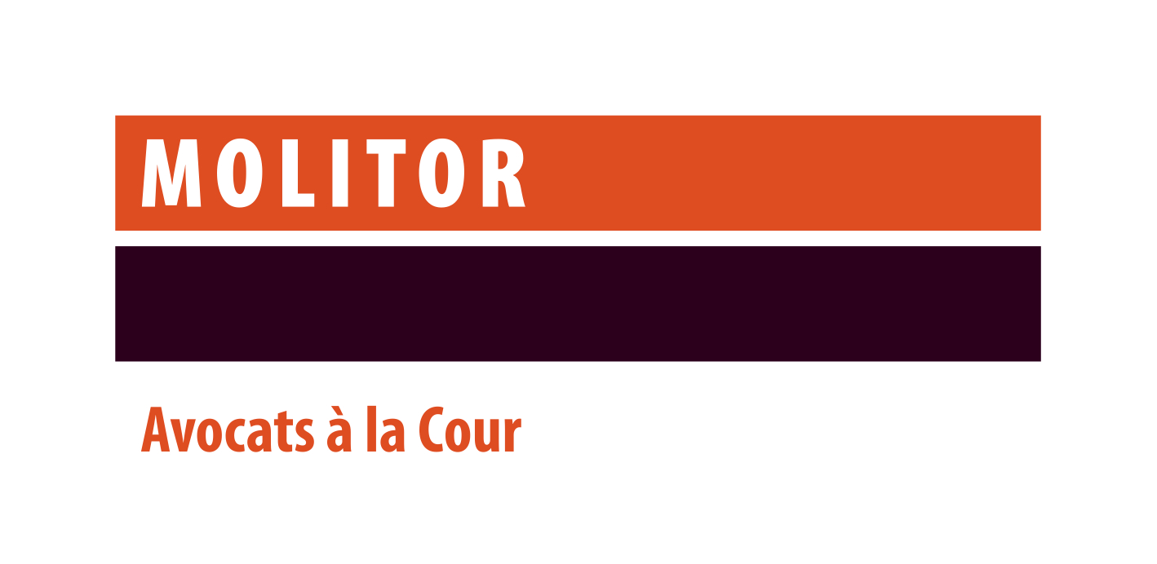

Contact: Isabelle Arbogast
HR Officer
isabelle.arbogast@molitorlegal.lu

MOLITOR Avocats à la Cour is currently searching for a

LAWYER
Data Protection, Technologies & IP

We are seeking an experienced and dynamic lawyer to join our team with deep expertise in personal data protection, technology law, and intellectual property, paired with a strong passion for contract law and commercial law.

You will
- handle data protection matters such as advising clients on GDPR implementation (drafting policies and internal procedures, data processing agreement), data breaches, data transfers;
- draft, analyse and review contracts, ensuring they meet both legal and business requirements.
- provide legal advice on the full range of intellectual property matters, including copyrights, databases, registered design, trademark, domain names and unfair competition issues;
- In the field of media law, advising clients with respect to marketing and advertising projects for all kind of media;
- Work closely with various departments including M&A, Employment and Tax to support our clients’ legal needs and facilitate smooth operations.

Your profile
- University degree in law completed by a post-graduate degree;
- Member of the Luxembourg Bar or EU Bar:
- At least 3-4 years’ experience in a recognized law firm and a solid background in data protection, technologies and IP;
- Personal communications skills;
- Excellent written communication and drafting skills;
- Fluent (written and spoken) in both French and English. Proficiency in Luxembourgish and German would be highly appreciated;
- Ability to navigate and interpret regulatory changes;
- A proactive, solution-oriented mindset with attention to detail and strong organizational skills.
- Dynamism, Curious about evolving tech market and team spirit.

What we offer
You will be part of an international team of lawyers, operating in an exciting business environment of a full-service law firm dealing with both domestic and international client networks. To foster your continuous professional development, we offer you both internal and external training. You will be challenged from day one and will be working both autonomously as well as in project teams.

We have a strong focus on how we recruit train and reward our staff and always ensure that they are fully aligned with our work culture built around our four fundamental values: Service Excellence, Integrity & Trust, Teamwork and Approachability.

Our staff work together cohesively, applying our key values of placing team goals above individual goals and focusing on building trust and rapport with our clients, who note that approachability is one of our differentiating traits, alongside service excellence.

